High Impact + High Sensitivity (e.g., LLIN in most settings): Critical to both effectiveness and uncertainty. Better to prioritize optimizing these interventions (e.g., ensuring actual coverage reaches operational targets, as well as ensuring usage)
High Impact + Low Sensitivity (e.g., SMC in some settings): Reliable (lower negative impact on disease outcomes if removed)
Low Impact + High Sensitivity (e.g., IRS): High potential if coverage is increased.
Low Impact + Low Sensitivity (e.g., vaccine currently): Lower priority

ID | Region (8) | Number of Settings (27) | Same intervention packages? | Intervention Packages /# of settings
1 | Ashanti | 5 | No (2) | LLIN, Vaccine / 3  IRS, vaccine / 2
2 | Central | 2 | Yes | LLIN, vaccine
3 | North East | 2 | No (2) | IRS, SMC, vaccine  IRS, SMC
4 | Northern | 5 | No (2) | IRS, SMC / 2  LLIN, SMC /3
5 | Savannah | 2 | Yes | LLIN, SMC
6 | Upper East | 4 | No (2) | IRS, SMC, vaccine / 2  LLIN, SMC, vaccine / 2
7 | Upper West | 4 | Yes | IRS, SMC, vaccine
8 | Western | 3 | Yes | LLIN, vaccine

###############################################
- How to estimate the right amount of resources on SciCore
- SlurmPrepareScenarios – memCPU 1GB, nCPU 10, bSize 200 (max)
- If someone in your group needs to use urgently, reduce the nCPU
- Create scenarios on OOD and run simulations on SciCore

- SlurmPrepareSimulations – 5 – 10 mins for small pops,

- Increase Ncpu, reduce memCPU

- Use “control update Job ID= 1022839 ArrayTaskThrottle =20” to limit the resources

- Check scicore page

- Ncdu -

- SlurmPrepareResults
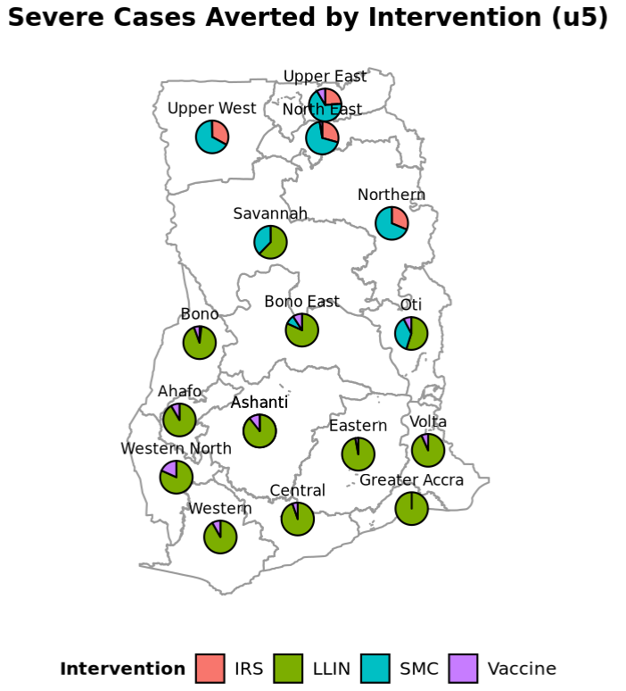
4
1

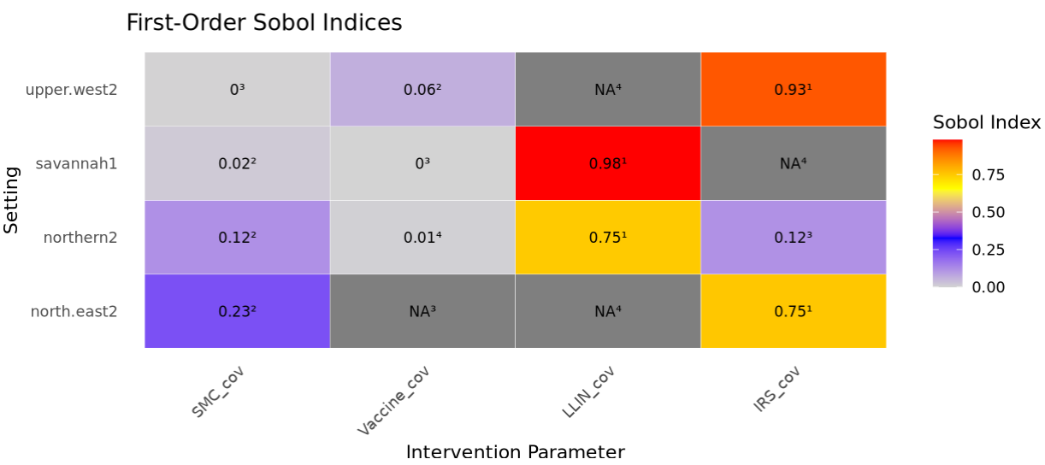
3
2
4
1

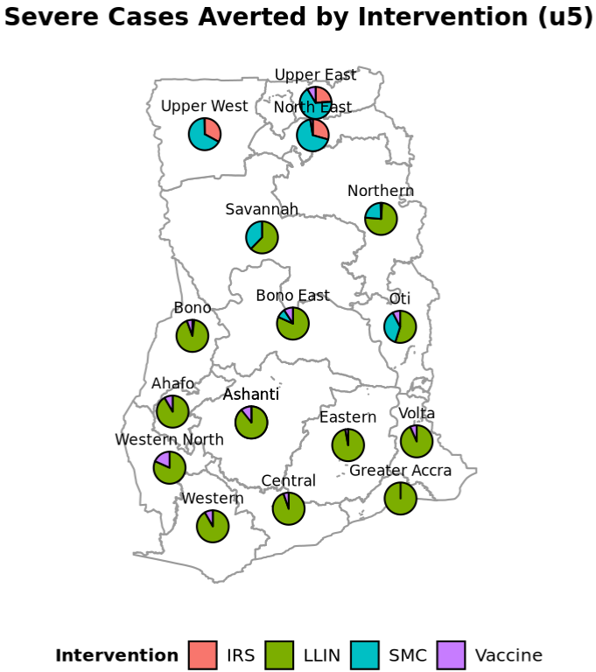
3
4
1
2

